Insert 10 rows into both tables, as given below.

Create a table named Country with fields: Id, Country_name, Population, Area

Create another table named Persons with fields: Id ,Fname, Lname ,Population, Rating ,Country_Id ,Country_name.

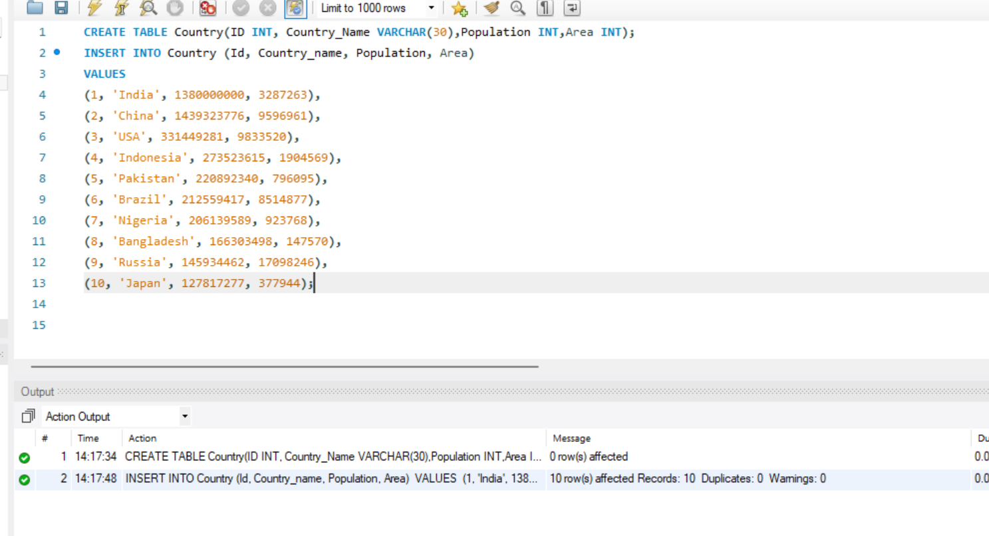

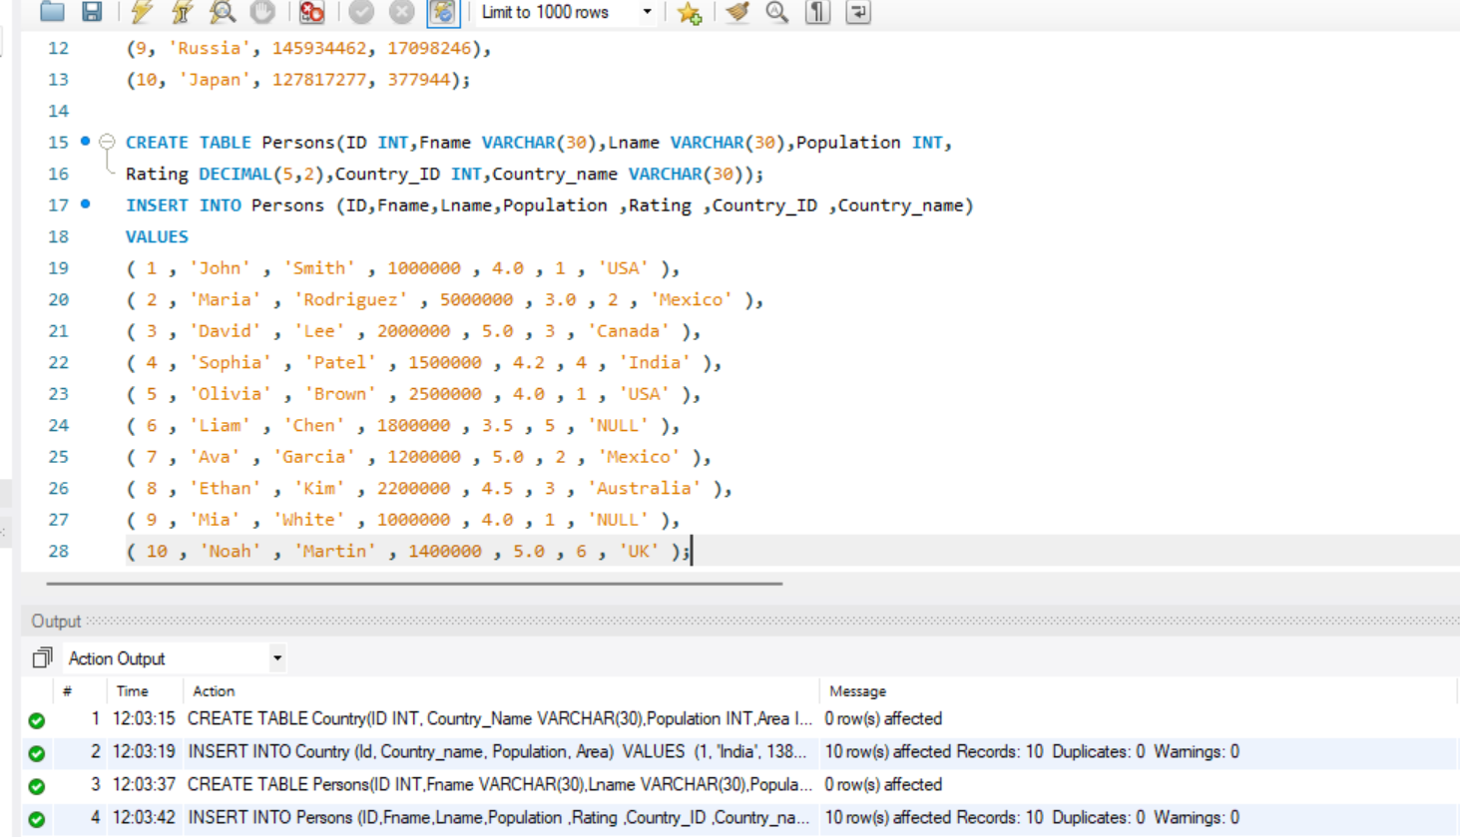

1)List the distinct country names from the Persons table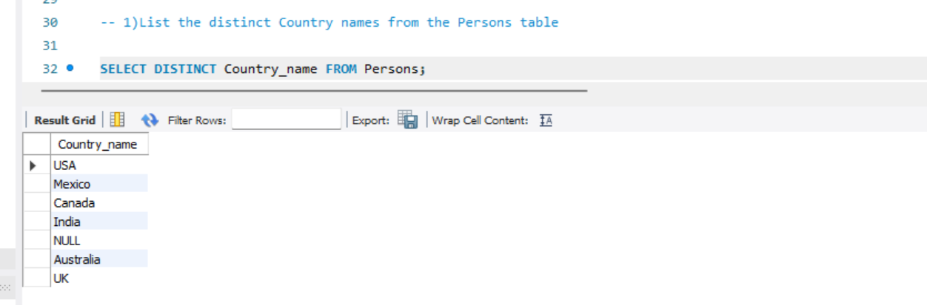

(2)Select first names and last names from the Persons table with aliases.

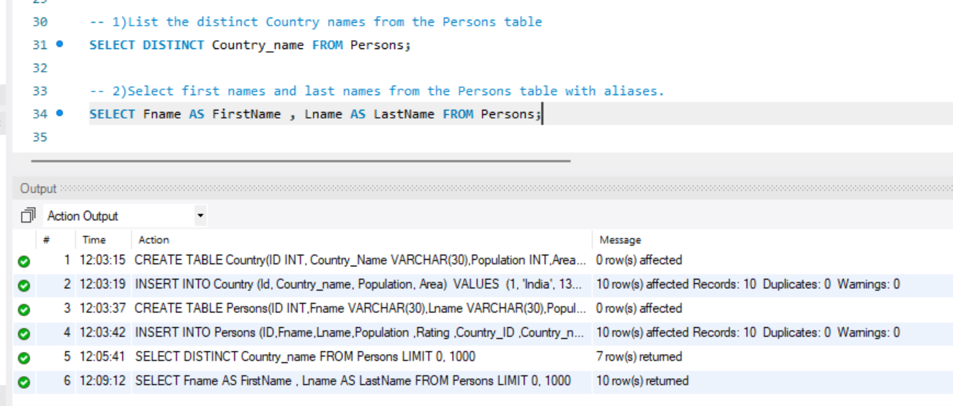

(3)Find all persons with a rating greater than 4.0.

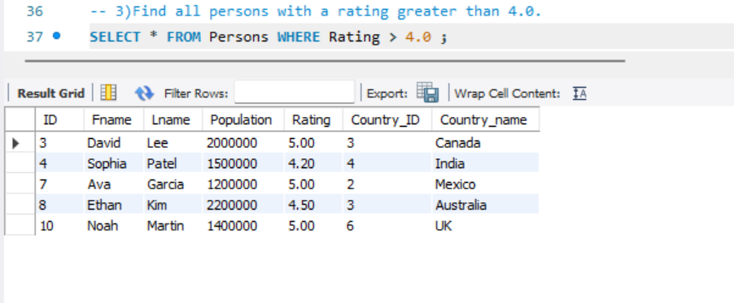

(4)Find countries with a population greater than 10 lakhs.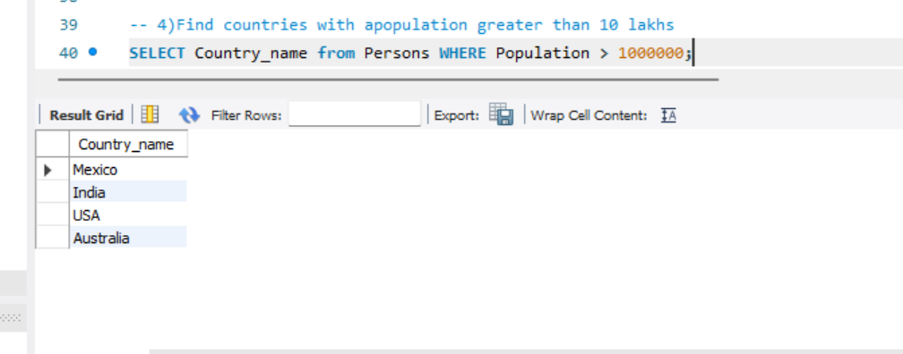

(5)Find persons who are from 'USA' or have a rating greater than 4.5.

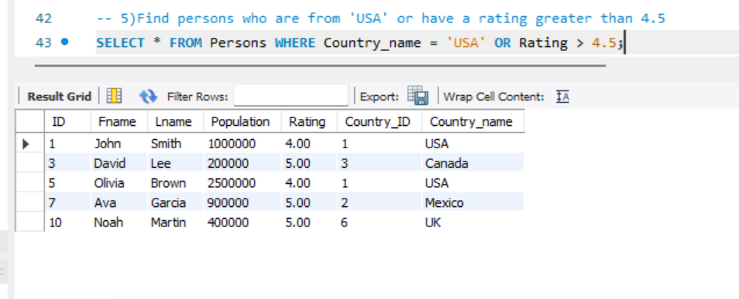

(6)Find all persons where the country name is NULL

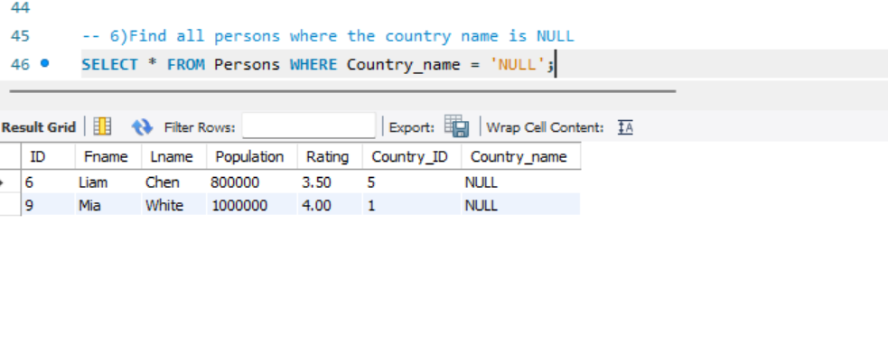

(7)Find all persons from the countries 'USA', 'Canada', and 'UK'.

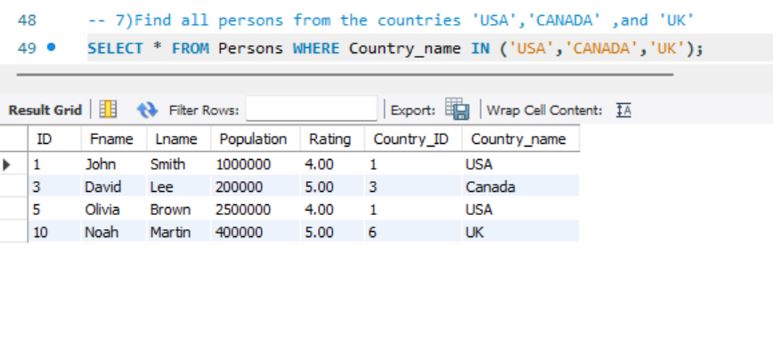

(8)Find all persons not from the countries 'India' and 'Australia'.

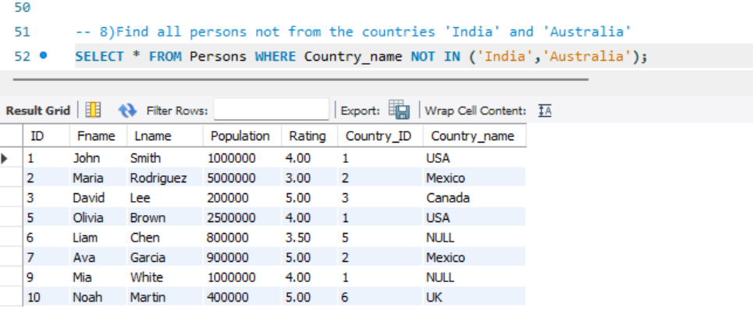

(9)Find all countries with a population between 5 lakhs and 20 lakhs

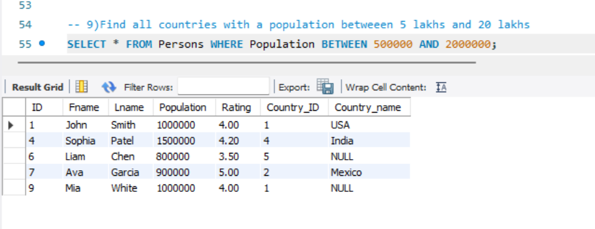

(10)Find all countries whose names do not start with 'C'.